21.Write a Pandas program to swap the cases of a specified character column in a given
DataFrame.

Aim:
To write a Pandas program to swap the uppercase and lowercase characters in a specified DataFrame column.
Code:
import pandas as pd
data = {
"Name":["John","ALICE","DaVid","EMMA"]
}
df = pd.DataFrame(data)
df["Name"] = df["Name"].str.swapcase()
print(df)
Output:
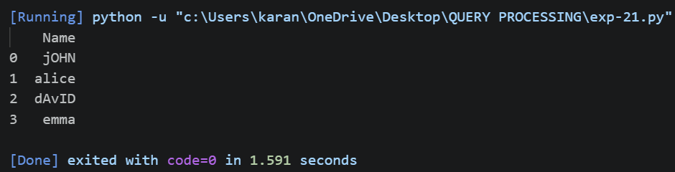

Result:
Thus, the Pandas program was successfully executed to swap the cases of the characters in the Name column.

22.Write a Python program to draw a line with suitable label in the x axis, y axis and a
title.
Aim:
To write a Python program to draw a line plot with suitable labels for the X-axis, Y-axis, and title.

Code:
import matplotlib.pyplot as plt
x = [1,2,3,4,5]
y = [2,4,6,8,10]
plt.plot(x, y)
plt.xlabel("X-Axis")
plt.ylabel("Y-Axis")
plt.title("Simple Line Plot")
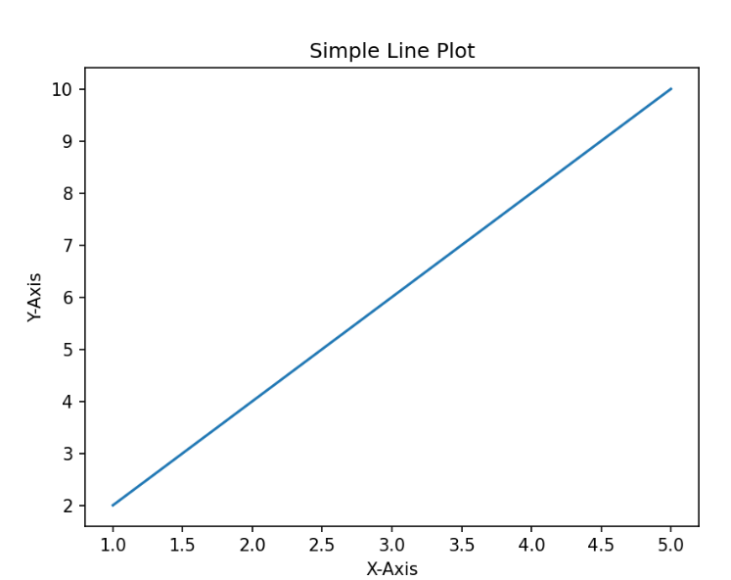
plt.show()
Output:

Result:
Thus, the Python program was successfully executed to draw a line plot with X-axis, Y-axis labels and a suitable title.

